C01 Assessment Tool 2 TOC(CSA1305) Student Name: K Gayathri Reg.No:192311448

Question 1: Design of a Non-Deterministic Finite Automaton (NFA) for an Automatic Door System
Aim
To design and simulate a Non-Deterministic Finite Automaton (NFA) for an Automatic Door System based on sensor inputs using AutoSim.

Procedure
- Open the AutoSim software.
- Create four states:
  - q0 – Closed (Initial State)
  - q1 – Opening
  - q2 – Open
  - q3 – Closing
- Set q0 as the initial state.
- Set q0 as the final (accepting) state since the door finally returns to the closed position.
- Use the input alphabet:
  - P = Person detected
  - N = No person detected
- Add the following transitions:
From State | Input | To State
q0 | a | q1
q1 | a | q2
q1 | b | q2
q2 | a | q2
q2 | b | q2
q2 | b | q3
q3 | b | q0
q3 | a | q1
- Save the automaton.
- Click Run/Simulate.
- Enter test input strings such as PP, PPN, or PPNN and verify the state transitions.
- Observe the output and verify that the NFA behaves as expected.
Output:

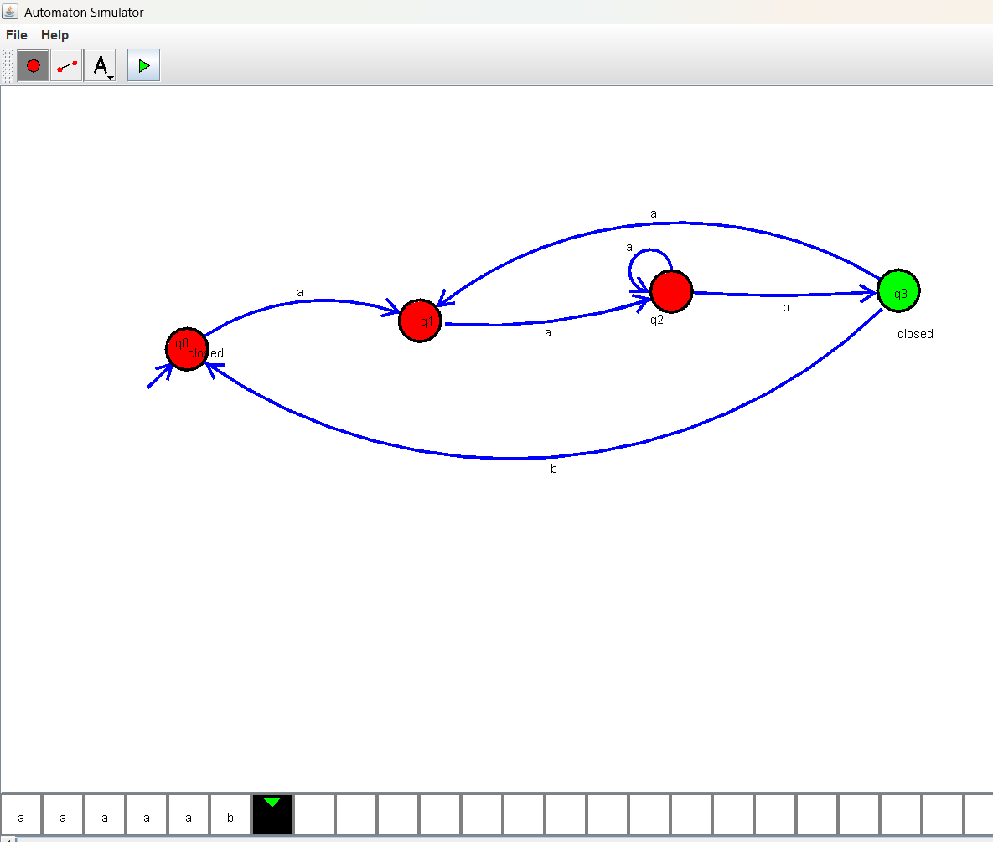
Result
Thus, the NFA for the Automatic Door System was successfully designed and verified using AutoSim.
Question 2: Design of a DFA for a Traffic Light Control System
Aim
To design and simulate a Deterministic Finite Automaton (DFA) for a Traffic Light Control System using AutoSim, representing the sequence of traffic signals (Red → Green → Yellow → Red).

Procedure
- Open the AutoSim software.
- Create three states:
  - q0 – Red
  - q1 – Green
  - q2 – Yellow
- Set q0 as the initial state.
- Since the traffic light operates continuously, all states (q0, q1, q2) may be treated as accepting states (or as required by your simulator).
- Use the input symbol:
  - T = Timer expires (or timer signal)
- Add the following transitions:
From State | Input | To State
q0 | a | q1
q1 | a | q2
q2 | a | q0
- Save the DFA.
- Click Run/Simulate.
- Enter the input string aaa (or multiple as such as aaaaa) to observe the cyclic transitions.
- Verify that the traffic light changes in the order Red → Green → Yellow → Red repeatedly.
OUTPUT
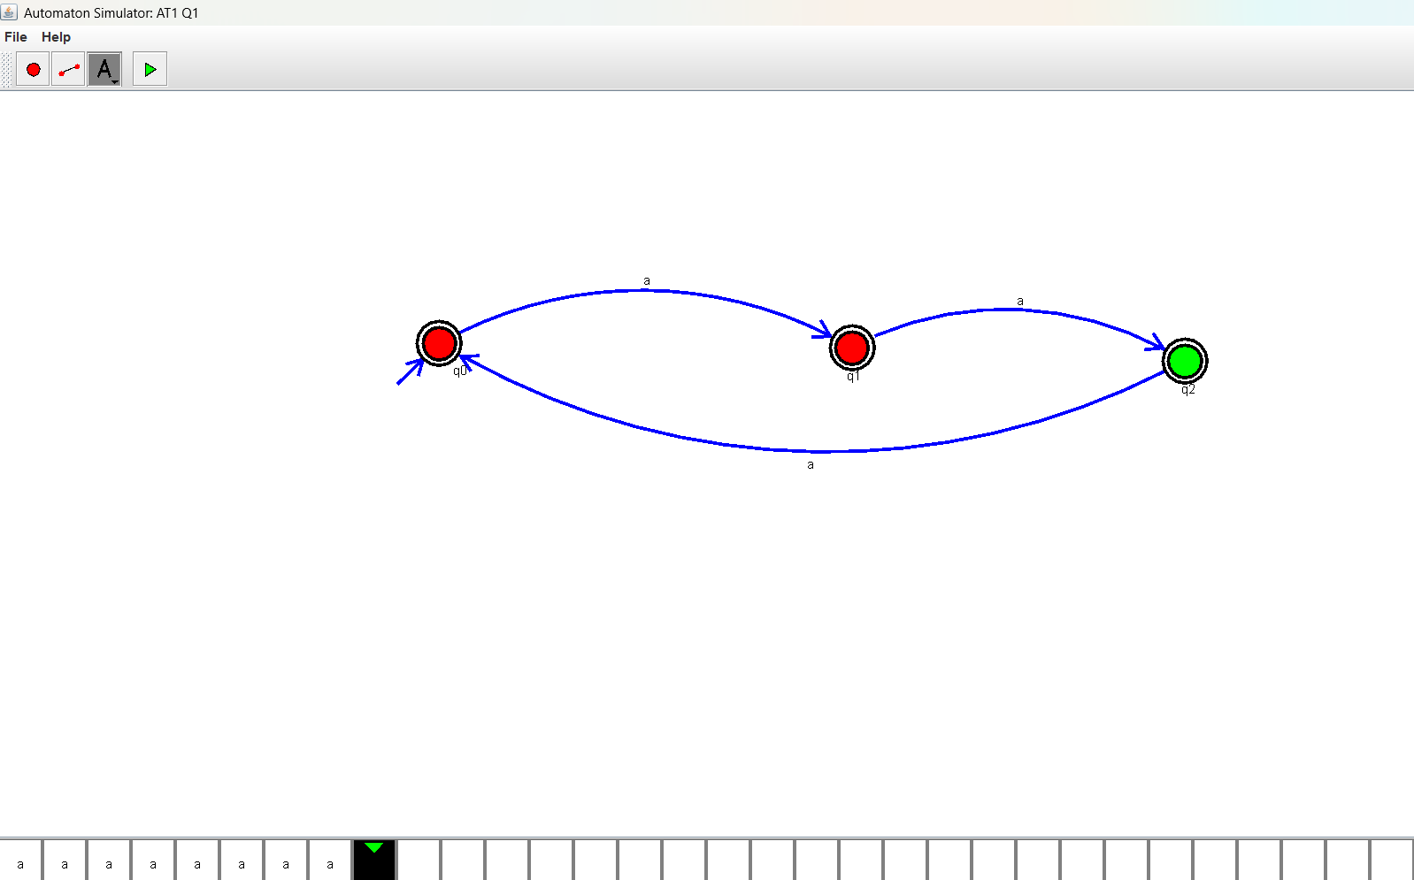
Result
Thus, the DFA for the Traffic Light Control System was successfully designed and verified using AutoSim. The automaton correctly implements the sequence Red → Green → Yellow → Red in a continuous cycle.
Experiment 3: Design a DFA to Accept Strings Ending with "ab" over the Alphabet {a, b}
Aim
To design and simulate a Deterministic Finite Automaton (DFA) using AutoSim that accepts all strings ending with "ab" over the alphabet {a, b}.

Alphabet
$$Σ=\left\{a , b\right\}$$

States
- q0 – Initial state
- q1 – Last symbol read is a
- q2 – String ends with ab (Final State)

Initial State
q0
Final State
q2
Transition Table
Current State | Input a | Input b
q0 | q1 | q0
q1 | q1 | q2
q2 | q1 | q0
Procedure
- Open the AutoSim software.
- Create three states: q0, q1, and q2.
- Set q0 as the initial state.
- Set q2 as the final (accepting) state.
- Use the input alphabet {a, b}.
- Add the transitions according to the transition table.
- Save the DFA.
- Click Run/Simulation.
- Enter input strings such as ab, aaab, bab, and aaabab.
- Verify that only strings ending with "ab" are accepted.
Output:
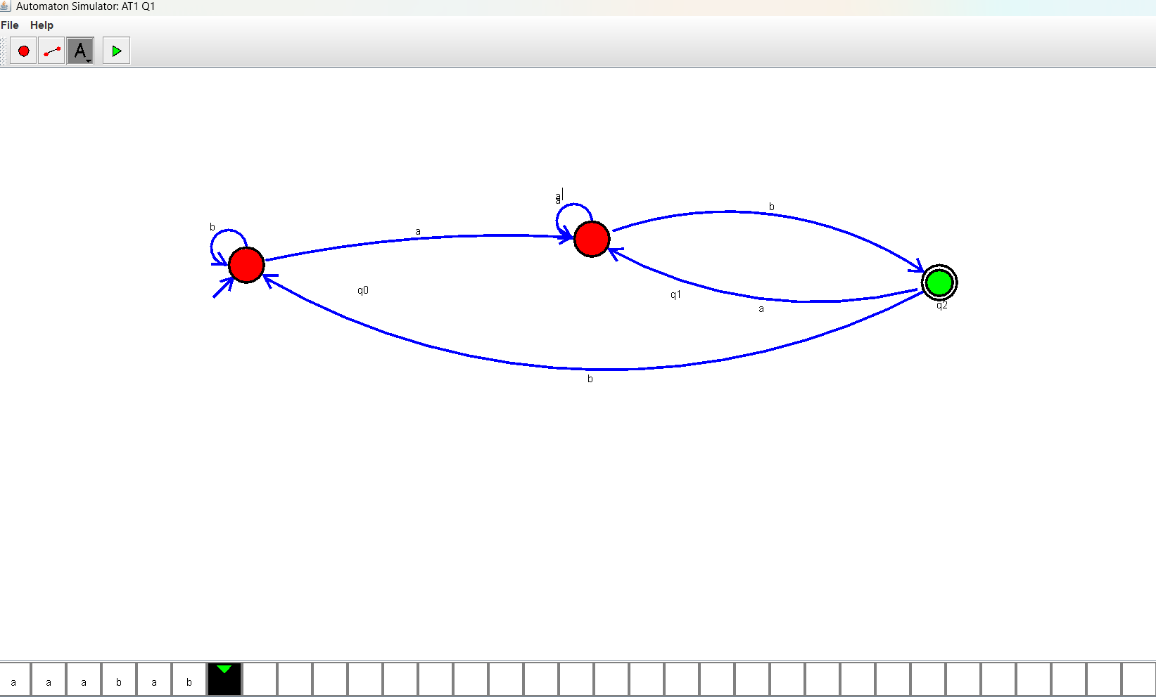
Result
Thus, the Deterministic Finite Automaton (DFA) to accept all strings ending with "ab" over the alphabet {a, b} was successfully designed and verified using AutoSim.

Experiment 4: Design a DFA to Accept Only the Strings "c", "bc", and "bcaaa"
Aim
To design and simulate a Deterministic Finite Automaton (DFA) using AutoSim that accepts only the strings "c", "bc", and "bcaaa" over the alphabet {a, b, c}.

Alphabet
$$Σ=\left\{a , b , c\right\}$$

States
- q0 – Initial state
- q1 – After reading b
- q2 – After reading c (Final state for "c" and "bc")
- q3 – After reading bca
- q4 – After reading bcaa
- q5 – After reading bcaaa (Final state)
- qd – Dead state

Initial State
q0

Final States
q2, q5

Transition Table
Current State | a | b | c
q0 | qd | q1 | q2
q1 | qd | qd | q2
q2 | q3 | qd | qd
q3 | q4 | qd | qd
q4 | q5 | qd | qd
q5 | qd | qd | qd
qd | qd | qd | qd

Output:
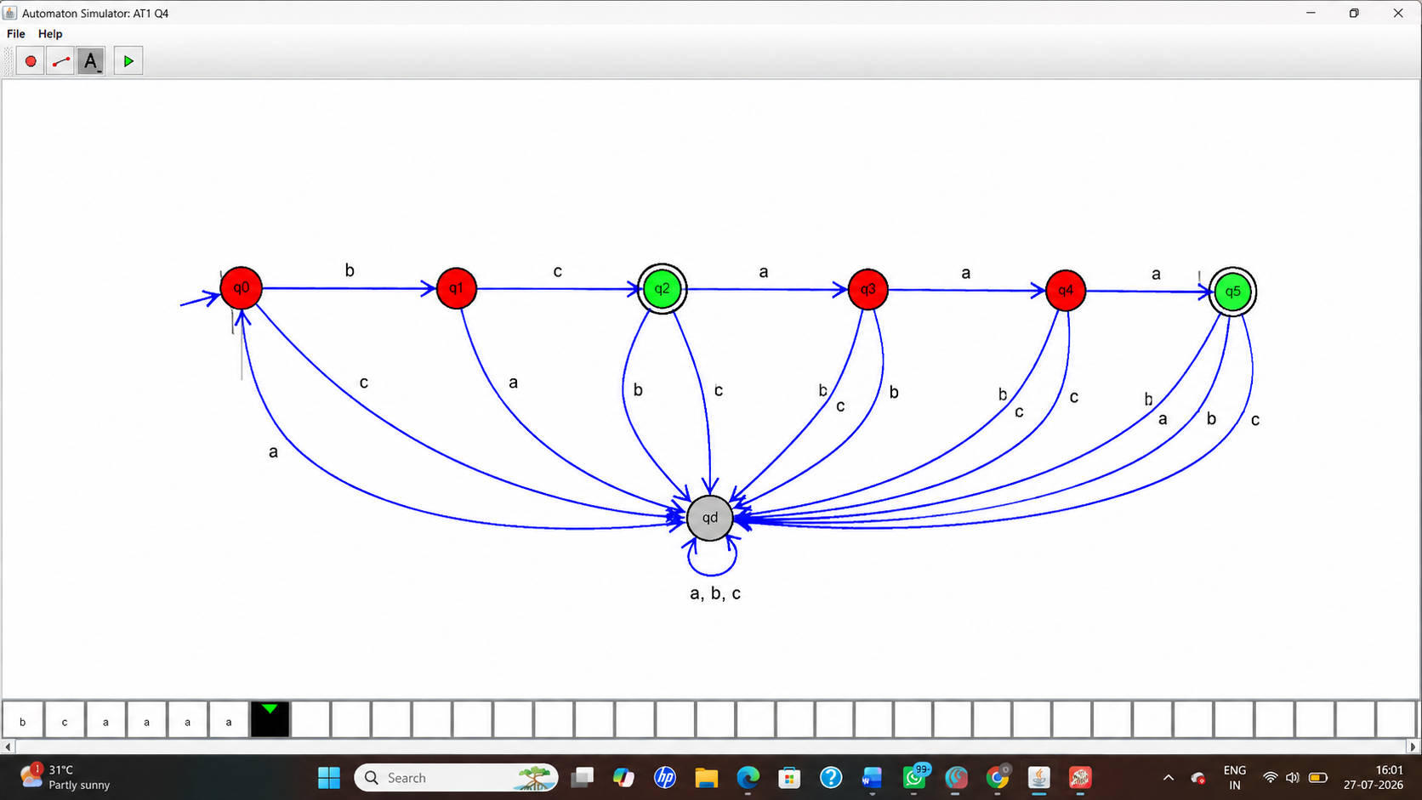
Result
Thus, the Deterministic Finite Automaton (DFA) to accept only the strings "c", "bc", and "bcaaa" over the alphabet {a, b, c} was successfully designed and verified using AutoSim.
Experiment 5: Design a DFA to Accept All Strings Beginning with 'a' or 'b'
Aim
To design and simulate a Deterministic Finite Automaton (DFA) using AutoSim that accepts all non-empty strings over the alphabet {a, b} which begin with either 'a' or 'b'.

Alphabet
$$Σ=\left\{a , b\right\}$$
States
- q0 – Initial state
- q1 – Accepting (Final) state
Initial State
q0
Final State
q1
Transition Table
Current State | Input a | Input b
q0 | q1 | q1
q1 | q1 | q1

Procedure
- Open the AutoSim software.
- Create two states: q0 and q1.
- Set q0 as the initial state.
- Set q1 as the final (accepting) state.
- Use the input alphabet {a, b}.
- Add the following transitions:
  - q0 → q1 on input a
  - q0 → q1 on input b
  - q1 → q1 on input a
  - q1 → q1 on input b
- Save the DFA.
- Click Run/Simulation.
- Test the automaton with different input strings such as a, b, ab, ba, aab, and bba.
- Verify that all non-empty strings beginning with a or b are accepted.
DFA Diagram :
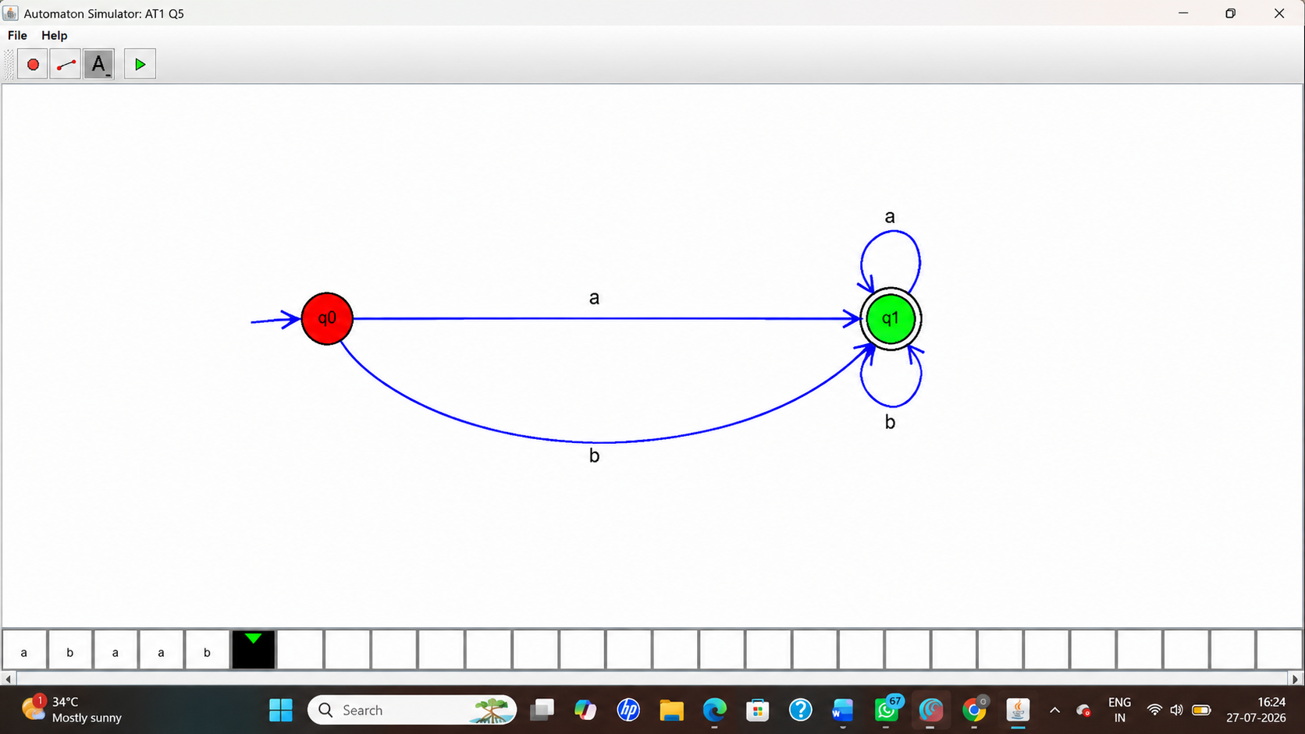

Sample Input and Output
Input String | Result
a | Accepted
b | Accepted
ab | Accepted
ba | Accepted
aab | Accepted
bba | Accepted
ε (empty string) | Rejected

Result
Thus, the Deterministic Finite Automaton (DFA) to accept all non-empty strings over the alphabet {a, b} beginning with 'a' or 'b' was successfully designed and verified using AutoSim.

